**Project Design Phase**

**Solution Architecture**

| Date | 15 February 2025 |
| --- | --- |
| Team ID |  |
| Project Name |  |
| Maximum Marks | 4 Marks |

### Solution Architecture Description:

TravelSphere is an all-in-one travel ecosystem that integrates flight booking, agency management, real-time communication, and community interaction. The solution architecture is designed using a microservices-based approach, which ensures modularity, scalability, and performance.

### Key Goals of the Solution Architecture:

* **Identify and implement the best technologies (React.js, Spring Boot, MongoDB, Redis, WebSocket) to address core travel-related pain points.**
* **Visualize and describe the entire software structure for all stakeholders including developers, investors, and customers.**
* **Define essential system modules such as user profiles, post/feed, chat, agency panel, admin dashboard, and APIs for seamless functioning.**
* **Break down the architecture into clearly defined front-end, back-end, data layer, and communication components.**

### Solution Features & Components:

| **Layer** | **Technologies Used** | **Description** |
| --- | --- | --- |
| **Frontend** | **React.js** | **User interface with sections for Flights, Feed, Profile, Chat, Agency** |
| **Backend** | **Spring Boot** | **Handles business logic, RESTful APIs, user authentication, and admin services** |
| **Database** | **MongoDB** | **Stores user data, travel posts, agency info, flight data** |
| **Cache Layer** | **Redis** | **Improves performance through in-memory caching** |
| **Real-Time Messaging** | **WebSocket** | **Enables live chat between users and agencies** |
| **External APIs** | **Flight APIs** | **Fetch real-time flight info and pricing** |
| **Admin & Agency Panels** | **Custom dashboards** | **Used to manage users, flights, and engagement tools** |

### 

Fig: Data flow Diagram

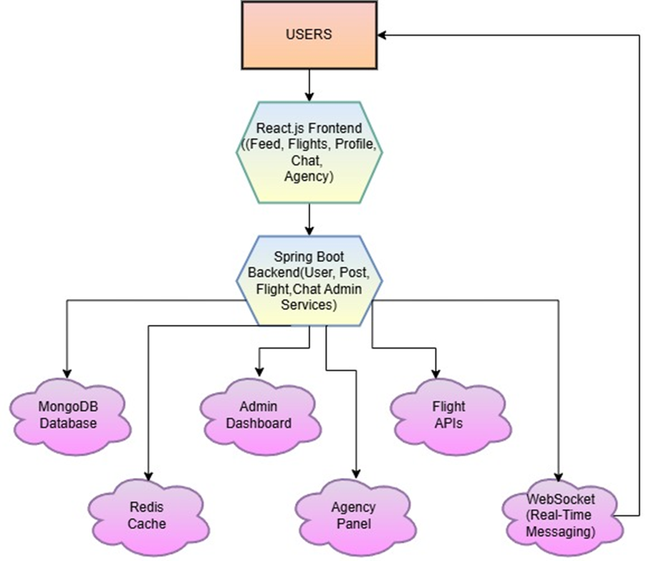

Fig: System Architecture Diagram

|  |  |  |
| --- | --- | --- |
|  |  |  |
|  |  |  |
|  |  |  |
|  |  |  |
|  |  |  |
|  |  |  |
|  |  |  |

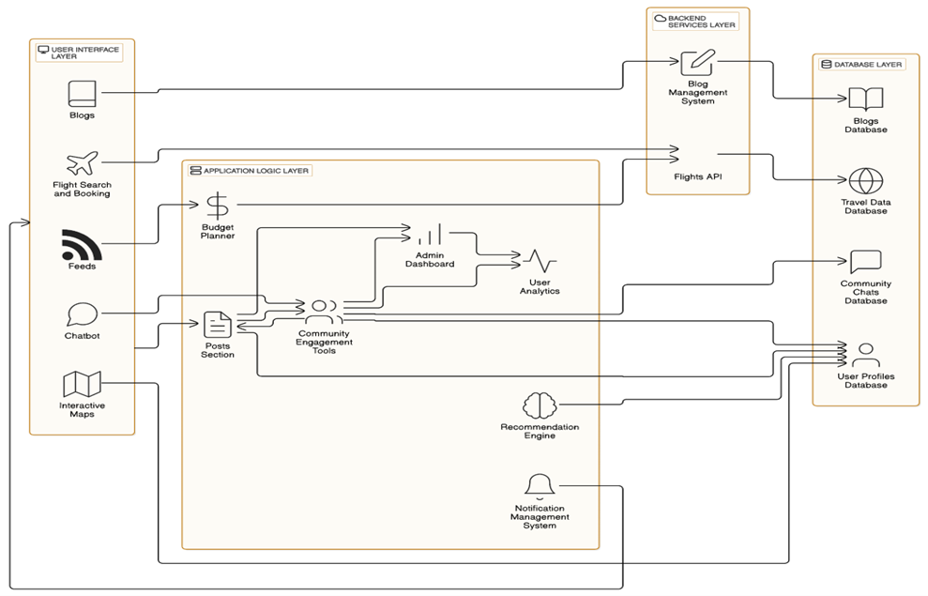

Fig: Layered Architecture of TravelSphere Application